TEMA: PLACAS BASE
INTEGRANTES:
- Ricardo Andres Bautista Diaz
- Javier Besada Soalleiro
- Nicolas Matias Primoy Pucheta

Rolando Raul Ocaña Parra

Cristian Celso Iglesias Rodríguez

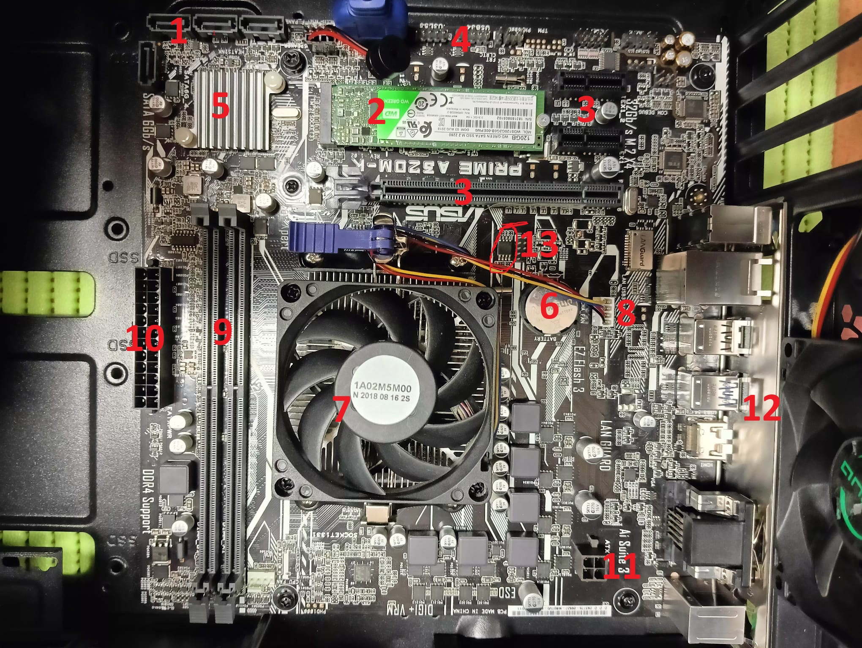
1: 4 Conectores SATA.
2: SSD NVME M.2
3: Dos ranuras PCI Express x1 y Una ranura PCI Express x16
4: Panel Frontal
5: Chipset (Puente Sur)
6: Pila CMOS
7: Zócalo (Microprocesador)
8: CPU Fan
9: 2 Ranuras DIMM DDR4
10: Conector ATX (24 Pines)
11: ATX (4 Pines)
12: Panel Trasero (Periféricos)
13: BIOS
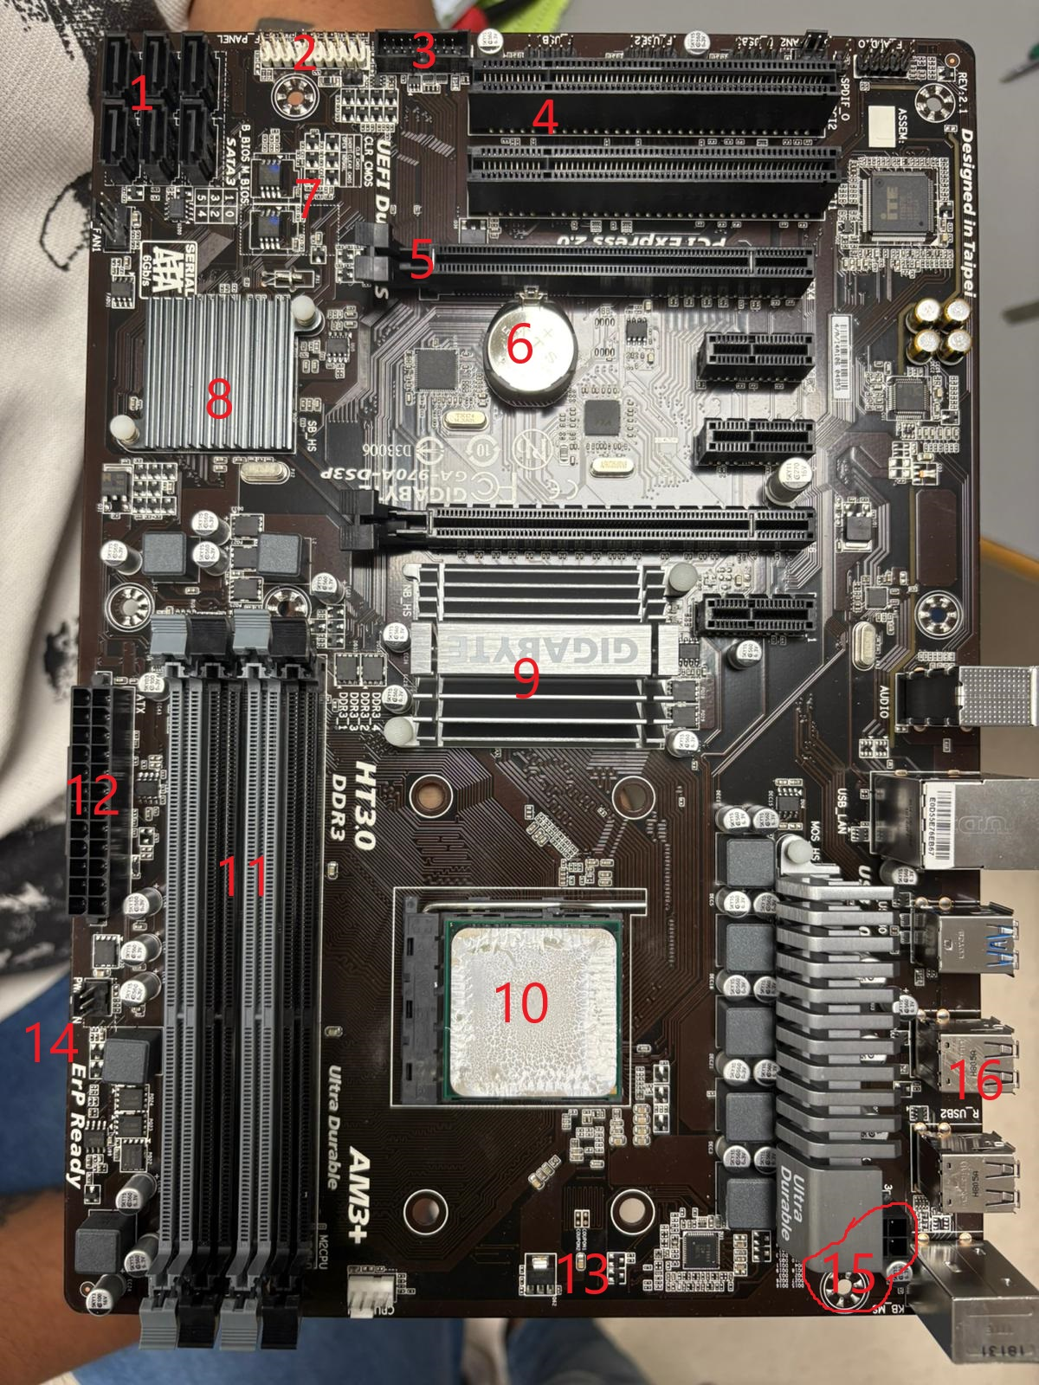
1: 6 Conectores SATA.
2: Panel Frontal
3: Frontal USB 3.0
4: 2 Entradas PCI
5: PCI Express x4
6: Pila CMOS
7: BIOS
8: Chipset (Puente Sur)
9: Chipset (Puente Norte)
10: Microprocesador
11: DIMM RAM DDR3
12: Conector ATX 24 Pines
13: CPU Fan
14: Pwr Fan
15: Conector ATX 12v
16: Panel Trasero (Periféricos)

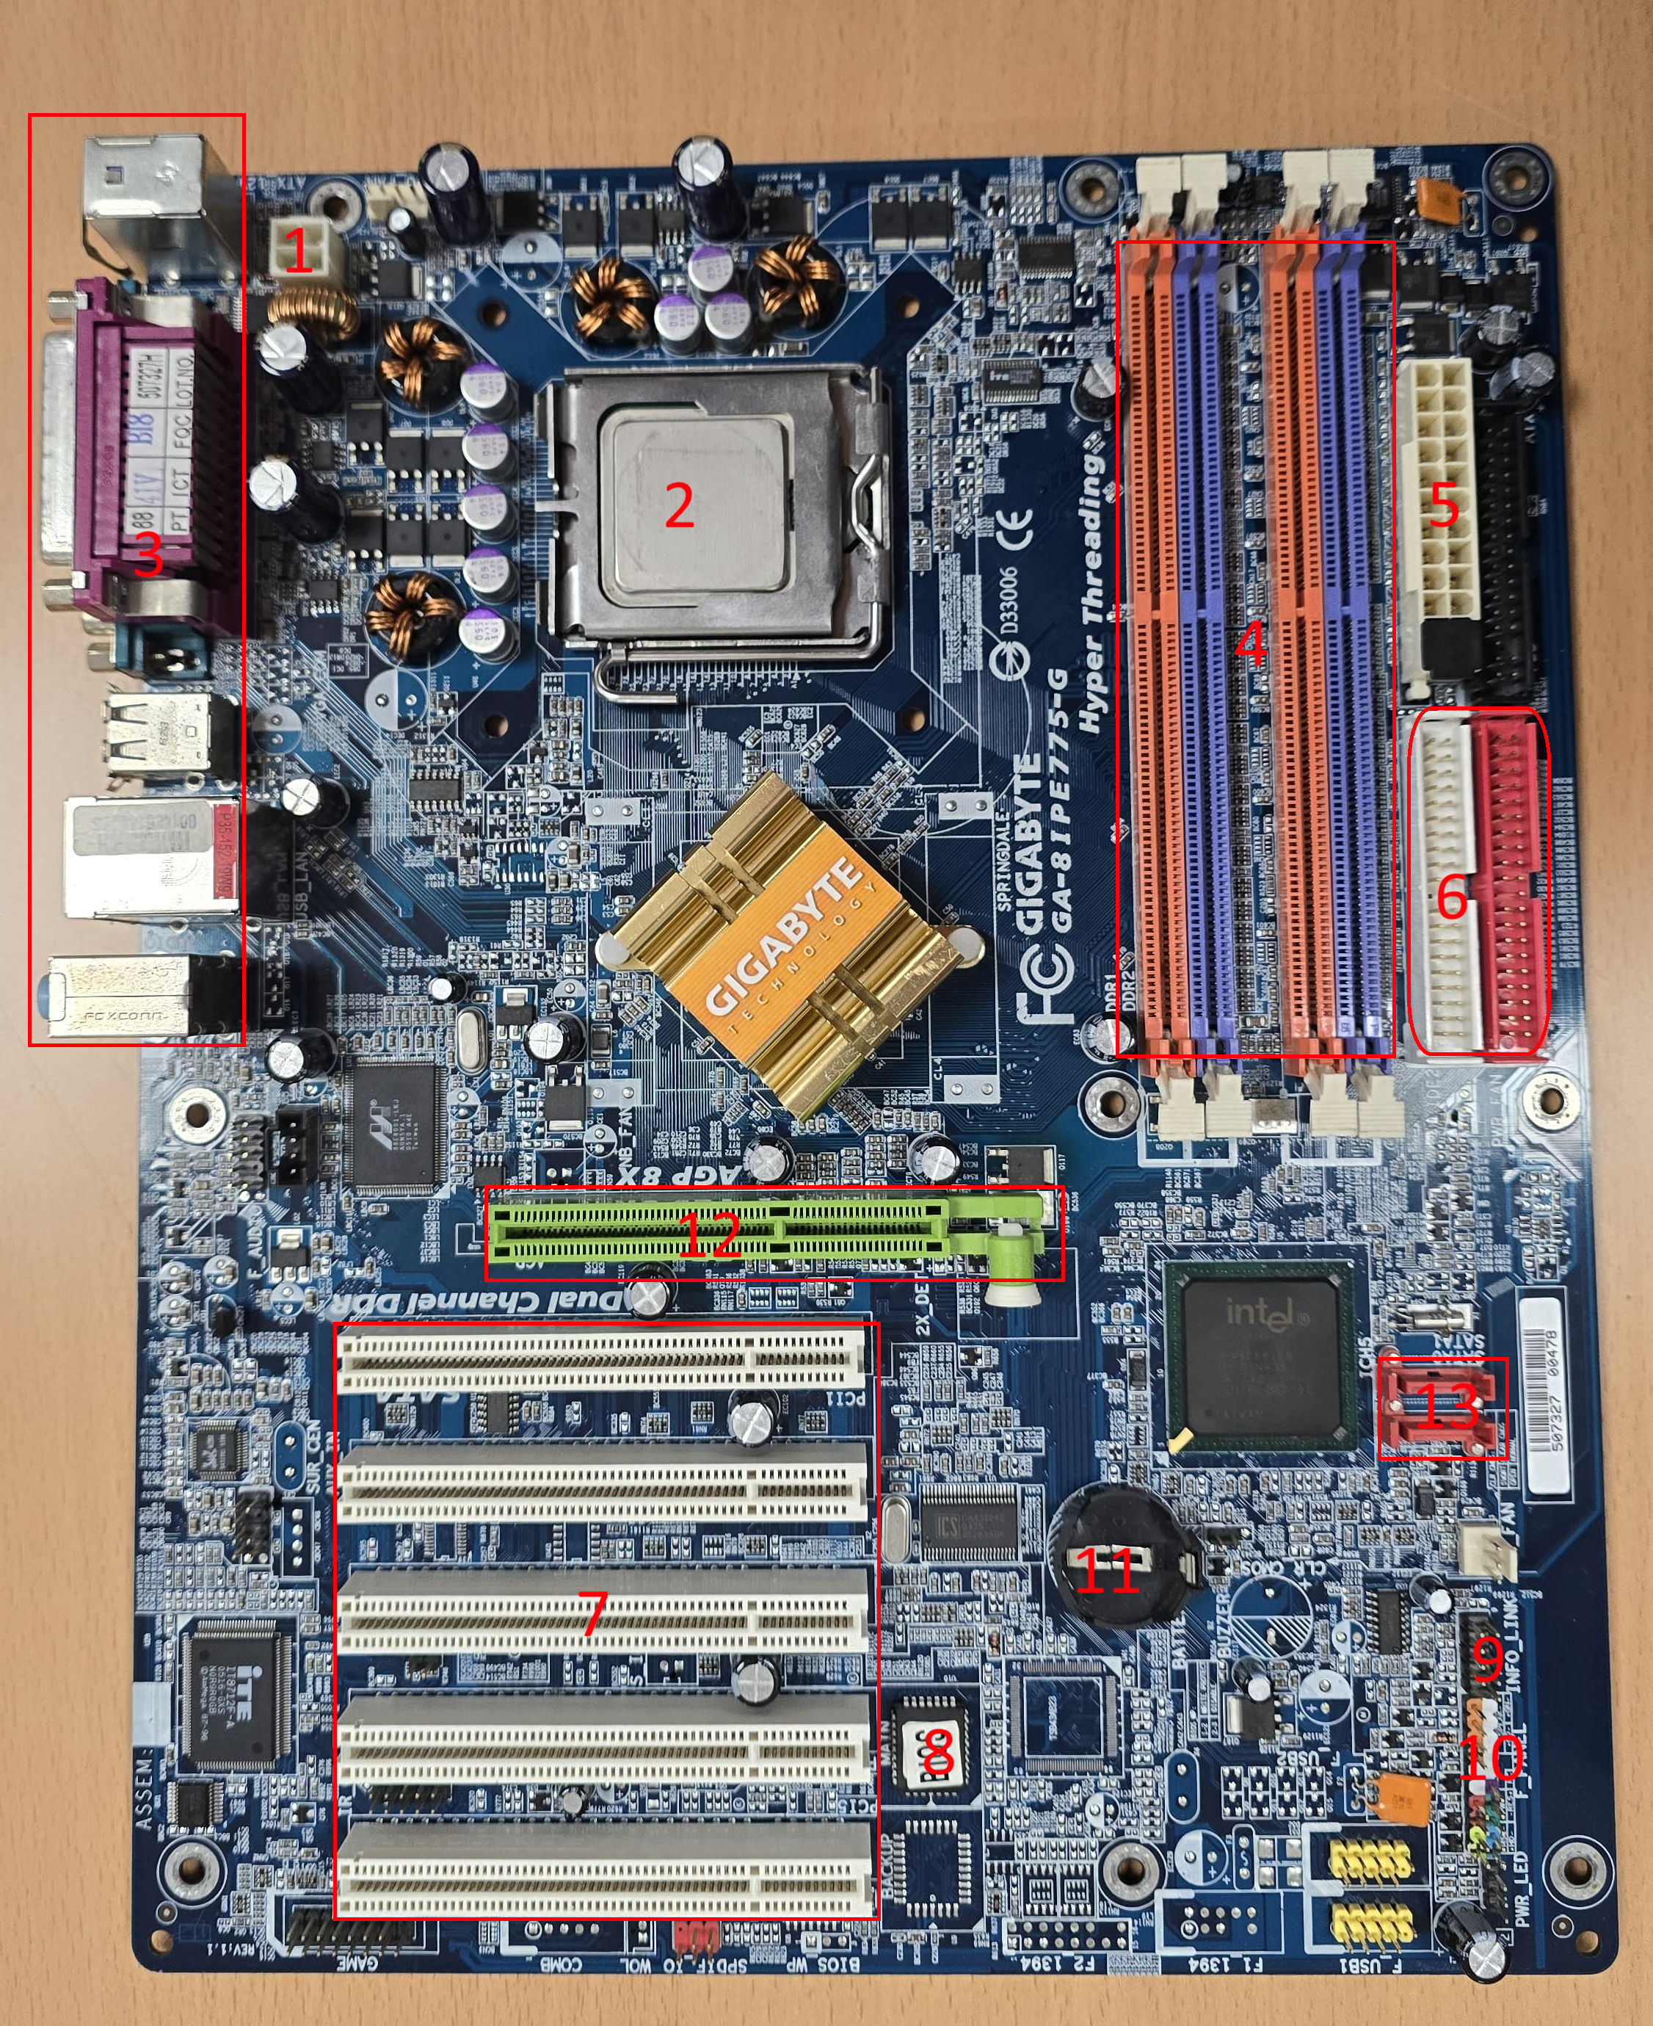

1: Conector ATX 12v
2: Socket procesador
3: Panel trasero (perifericos)
4: DIMM RAM DDR
5: Conector ATX 24 pines
6: Conector IDE
7: Conectores PCI
8: BIOS
9: Conector SYS_FAN
10: Panel frontal
11: Pila CMOS
12: Conector AGP
13: Conectores SATA
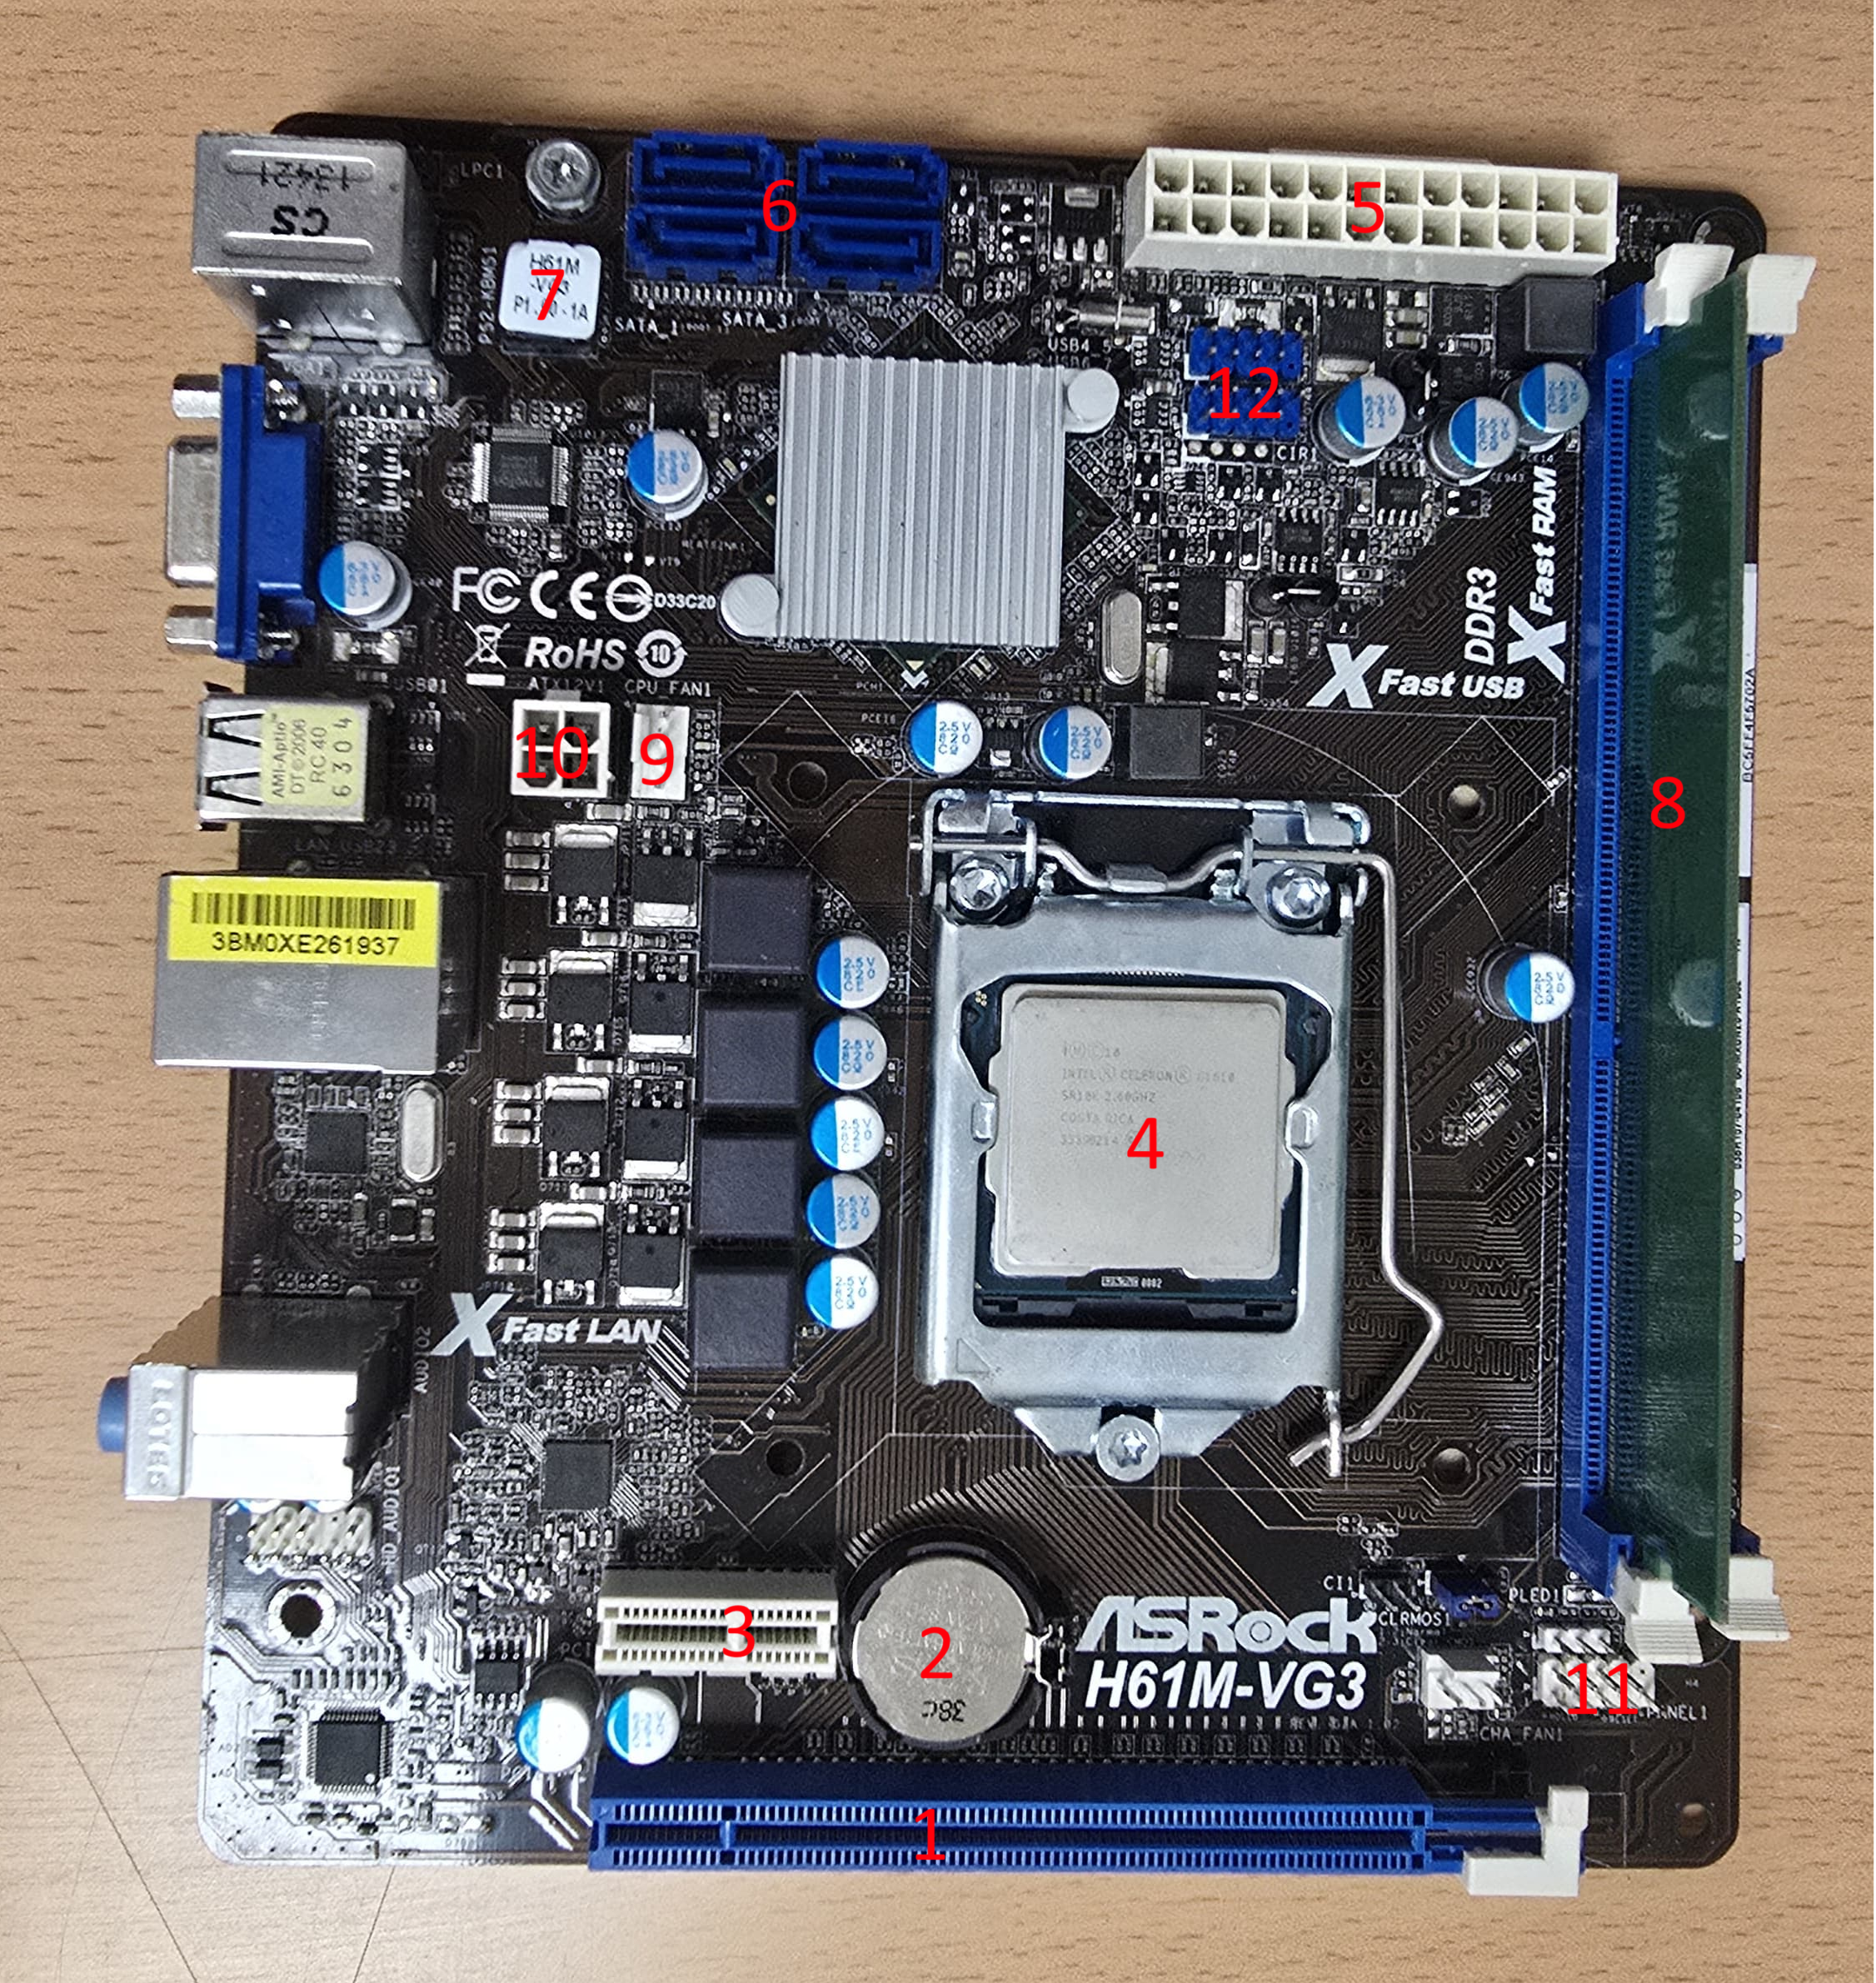
1: Conector PCI Express 3.0
2: Pila CMOS
3: Conector PCI Express 2.0
4: Socket micropocesador
5: Conector ATX 24 pines
6: Conectores SATA
7: BIOS
8: DIMM DDR3
9: Conector CPU FAN
10: Conector ATX 12v
11: Panel frontal
12: Conector USB 2.0 Header
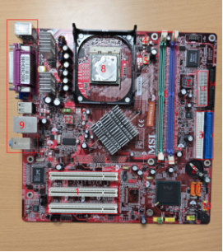
1: Conectores PCI
2: Pila CMOS
3: Conectores IDE
4: Conector CPU FAN
5: Conector SYS FAN
6: DIMM DDR
7: BIOS
8: Socket microprocesador
9: Panel trasero (perifericos)
10: Panel frontal
11: Conectores SATA
12: Conectores ATX 12v
13: Conector ATX 20 pines
14: Conector ATX 24 pines

